**Assignment #1 – Incident Response Fundamentals**

**Tasks:**

* Explain the four stages of incident response.

**Purpose:**

* Clarify: Understand the structured approach to handling and mitigating security incidents.
* Summarize: Describe each of the four stages of incident response and their significance in managing cybersecurity events effectively.

**Assignment:**

**Stages of Incident Response:**

1. **Preparation:** Establish and train an incident response team, develop and update incident response policies, and conduct regular security awareness training. Key activities include creating and maintaining incident response plans and setting up communication protocols.
2. **Detection and Analysis:** Identify potential security incidents through monitoring and alerting systems and analyze their nature and scope. Key activities involve using intrusion detection systems (IDS) and analyzing logs and alerts to confirm the incident.
3. **Containment, Eradication, and Recovery:** Implement measures to contain the incident, eliminate the threat, and restore systems to regular operation. Key activities include isolating affected systems, removing malware, and restoring backup data.
4. **Post-Incident Activity:** Conduct a thorough review of the incident, document findings, and update policies and procedures to prevent future incidents. Key activities include holding a post-incident debrief, identifying lessons learned, and refining incident response plans.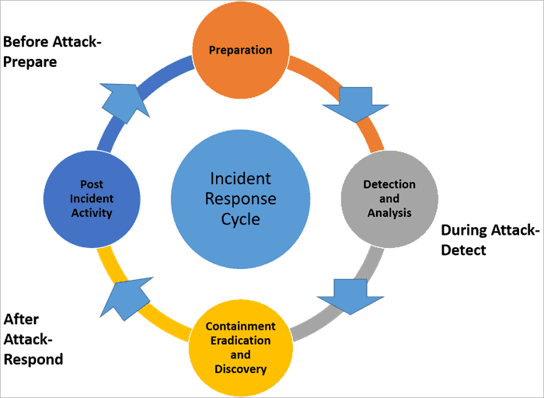

**Assignment #2 – Incident Response Fundamentals**

**Tasks:**

* What is incident response?

**Purpose:**

* Clarify: Understand the concept of incident response in the context of cybersecurity.
* Summarize: Explain the objectives of incident response and how it is executed within organizations.

**Assignment:**

**Incident Response:** Incident response is the process of identifying, managing, and mitigating cyber threats after they have breached network defenses. Its objectives include minimizing impact, managing recovery, and preventing future incidents. It involves detecting incidents, containing threats, eradicating malicious activity, and restoring normal operations.

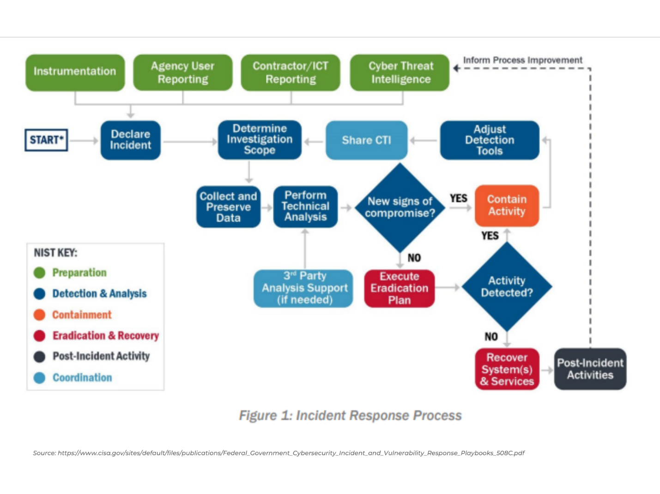**Assignment #3 – Digital Forensics and Incident Response**

**Tasks:**

* Explain the role of digital forensics in incident response.

**Purpose:**

* Clarify: Understand how digital forensics integrates with and supports the incident response process.
* Summarize: Describe how forensic principles and techniques are used to gather and analyze data after a security breach.

**Assignment:**

**Role of Digital Forensics in Incident Response:** Digital forensics is crucial in incident response for identifying how a breach occurred, who was involved, and what data was affected. Common forensic techniques include disk imaging, memory analysis, and log file analysis, which help in gathering and analyzing data to support legal and internal investigations.

**Assignment #4 – Digital Forensics and Incident Response**

**Tasks:**

* How do incident response teams use intrusion detection systems (IDS) during a cybersecurity incident?

**Purpose:**

* Clarify: Understand the application of IDS in the detection and analysis phase of incident response.
* Summarize: Describe how these systems contribute to identifying and responding to active security threats.

**Assignment:**

**Use of Intrusion Detection Systems (IDS):** Intrusion detection systems (IDS) monitor network traffic for suspicious activity and alert incident response teams to potential threats. IDS types include network-based and host-based systems. Data from IDS helps pinpoint the nature and scope of an intrusion, guiding the response team in mitigating threats effectively.

**Assignment #5 – Incident Response Training**

**Tasks:**

* What are IR tabletop exercises, and how do they benefit an incident response team?

**Purpose:**

* Clarify: Understand the concept and purpose of tabletop exercises in the context of incident response training.
* Summarize: Explain the structure of a tabletop exercise and how it prepares teams for real-life cybersecurity incidents.

**Assignment:**

**IR Tabletop Exercises:** Incident Response (IR) tabletop exercises simulate security incidents to test an incident response team’s reaction and decision-making processes. These exercises involve scenario-based discussions, allowing teams to practice skills, improve coordination, and identify weaknesses in response plans without the pressure of a real incident.

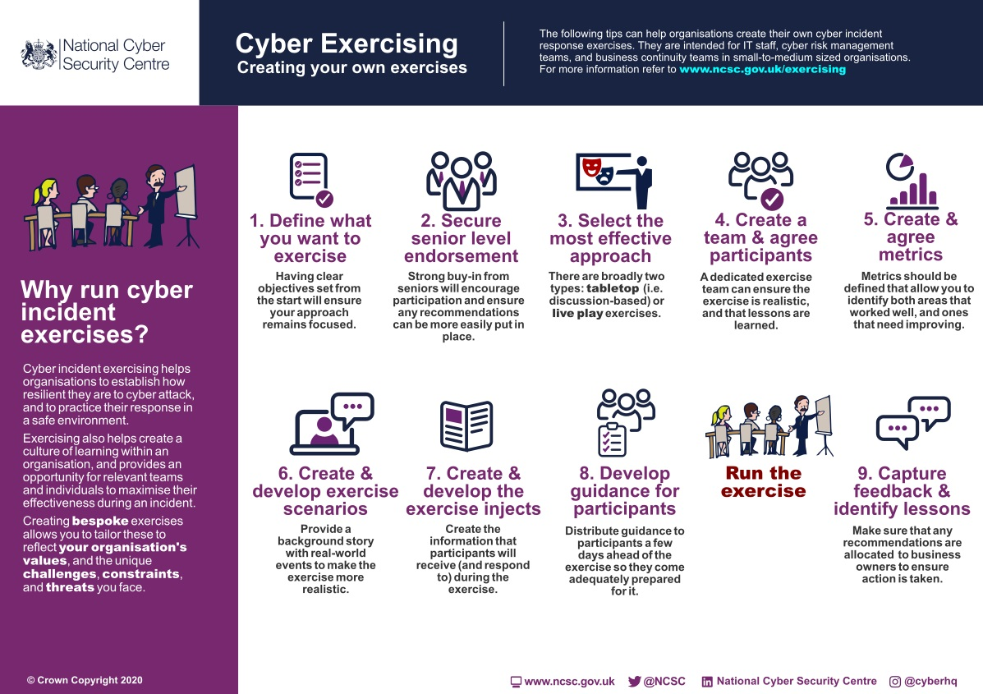 **Assignment #6 – Incident Response Training**

**Tasks:**

* Design a tabletop exercise scenario for a cybersecurity incident.

**Purpose:**

* Clarify: Develop practical skills in creating and executing incident response drills.
* Summarize: Generate a realistic cybersecurity incident scenario that tests various aspects of an incident response plan.

**Assignment:**

**Tabletop Exercise: Ransomware Attack Scenario**

**Scenario Overview**

Incident: Ransomware Attack  
Affected Assets: Customer Database, Email Server, Financial Records  
Objective: Test the response team's ability to detect, contain, and recover from a ransomware attack.

Exercise Timeline and Key Decision Points

1. Initial Detection:
   * Time: 0 Hours
   * Activity: IT detects unusual encryption activity.
   * Decision Point: Verify authenticity of the alert.
2. Response Coordination:
   * Time: 1 Hour
   * Activity: Incident Response Team (IRT) is assembled.
   * Decision Point: Establish secure communication channels and update stakeholders.
3. Containment:
   * Time: 2 Hours
   * Activity: Isolate affected systems and disable network shares.
   * Decision Point: Decide on network segment shutdown if necessary.
4. Eradication:
   * Time: 4 Hours
   * Activity: Identify and remove ransomware.
   * Decision Point: Determine method for removing ransomware and patch vulnerabilities.
5. Recovery:
   * Time: 8 Hours
   * Activity: Restore data from backups and validate data integrity.
   * Decision Point: Ensure no residual threats and validate system functionality.
6. Debriefing and Lessons Learned:
   * Time: 24 Hours Post-Incident
   * Activity: Conduct a post-incident review.
   * Decision Point: Document findings, update response plans, and implement improvements.

Templates and Documentation

Incident Log Template:

* Incident ID: [Unique ID]
* Date and Time: [Start Time]
* Description of Incident: [Brief Description]
* Affected Assets: [List of Systems]
* Response Actions: [Actions Taken]
* Resolution: [Steps Taken]
* Follow-Up Actions: [Post-Incident Tasks]

Communication Plan Template:

* Stakeholders:
  + Internal: Executives, IT Team, IRT
  + External: Law Enforcement, Cybersecurity Experts
* Channels: Email, Phone, Messaging
* Schedule: Initial Notification, Regular Updates, Post-Incident Briefing

Response Checklist:

* Detection:
  + Verify alert
  + Notify IT and IRT
* Coordination:
  + Assemble IRT
  + Update stakeholders
* Containment:
  + Isolate systems
  + Disable network shares
* Eradication:
  + Remove ransomware
  + Patch vulnerabilities
* Recovery:
  + Restore from backups
  + Validate data integrity
* Debriefing:
  + Conduct review
  + Document findings
  + Update response plans

This shorter tabletop exercise provides a streamlined approach to testing the incident response team's readiness for a ransomware attack, covering key stages and decision points efficiently.

**Flowchart of the Tabletop Exercise: Ransomware Attack Scenario:**

graph TD

A[Initial Detection] -->|0 Hours| B[Verify Alert Authenticity]

B --> C[Assemble IRT]

C -->|1 Hour| D[Establish Secure Communication]

D --> E[Update Stakeholders]

E --> F[Isolate Affected Systems]

F -->|2 Hours| G[Disable Network Shares]

G --> H[Decide on Network Segment Shutdown]

H --> I[Identify and Remove Ransomware]

I -->|4 Hours| J[Patch Vulnerabilities]

J --> K[Restore Data from Backups]

K -->|8 Hours| L[Validate Data Integrity]

L --> M[Ensure No Residual Threats]

M --> N[Validate System Functionality]

N -->|24 Hours Post-Incident| O[Post-Incident Review]

O --> P[Document Findings]

P --> Q[Update Response Plans]

Q --> R[Implement Improvements]

**Explanation:**

1. **Initial Detection (0 Hours)**
   * Verify alert authenticity.
2. **Response Coordination (1 Hour)**
   * Assemble IRT.
   * Establish secure communication.
   * Update stakeholders.
3. **Containment (2 Hours)**
   * Isolate affected systems.
   * Disable network shares.
   * Decide on network segment shutdown if necessary.
4. **Eradication (4 Hours)**
   * Identify and remove ransomware.
   * Patch vulnerabilities.
5. **Recovery (8 Hours)**
   * Restore data from backups.
   * Validate data integrity.
   * Ensure no residual threats.
   * Validate system functionality.
6. **Debriefing and Lessons Learned (24 Hours Post-Incident)**
   * Conduct a post-incident review.
   * Document findings.
   * Update response plans.
   * Implement improvements.

**Response Checklists:**

**Initial Detection Checklist**

* Verify the authenticity of the alert.
* Identify the scope of the affected systems.
* Notify the Incident Response Team (IRT).

**Response Coordination Checklist**

* Assemble the Incident Response Team.
* Establish a secure communication channel.
* Update key stakeholders on the situation.

**Containment Checklist**

* Isolate affected systems from the network.
* Disable network shares and access to sensitive data.
* Decide on the necessity of shutting down network segments.

**Eradication Checklist**

* Identify and remove the ransomware from affected systems.
* Apply patches to vulnerabilities that were exploited.
* Perform a thorough scan to ensure all ransomware traces are eliminated.

**Recovery Checklist**

* Restore data from secure backups.
* Validate data integrity post-restoration.
* Ensure no residual threats remain in the system.
* Test system functionality and performance.

**Post-Incident Review Checklist**

* Conduct a debriefing session with the Incident Response Team.
* Document the incident response process, findings, and outcomes.
* Update response plans and protocols based on lessons learned.
* Implement improvements to prevent future incidents.

**Templates and Examples of Documentation:**

**Incident Log Template**

| **Timestamp** | **Event Description** | **Responsible Person** | **Status** |
| --- | --- | --- | --- |
| YYYY-MM-DD HH:MM:SS | Alert received | John Doe | Completed |
| YYYY-MM-DD HH:MM:SS | Verified authenticity of alert | Jane Smith | Completed |
| YYYY-MM-DD HH:MM:SS | Notified Incident Response Team | John Doe | Completed |
| YYYY-MM-DD HH:MM:SS | Isolated affected systems | IT Department | In Progress |

**Communication Plan Template**

* **Purpose:** Establish clear communication channels during the incident.
* **Stakeholders:**
  + Incident Response Team
  + IT Department
  + Executive Management
  + Public Relations
* **Communication Channels:**
  + Secure Email
  + Encrypted Messaging Apps
  + Dedicated Incident Response Hotline
* **Updates Frequency:**
  + Hourly during active incident
  + Daily post-incident until resolution

**Response Checklist Template**

* **Incident Detection:**
  + Verify alert authenticity
  + Identify affected systems
  + Notify IRT
* **Response Coordination:**
  + Assemble IRT
  + Establish secure communication
  + Update stakeholders
* **Containment:**
  + Isolate affected systems
  + Disable network shares
  + Consider network segment shutdown
* **Eradication:**
  + Remove ransomware
  + Patch vulnerabilities
  + Perform thorough system scan
* **Recovery:**
  + Restore data from backups
  + Validate data integrity
  + Ensure no residual threats
  + Test system functionality
* **Post-Incident Review:**
  + Conduct debriefing
  + Document findings
  + Update response plans
  + Implement improvements

Using these templates and checklists helps ensure a structured and efficient response to cybersecurity incidents, enhancing organizational readiness and resilience.